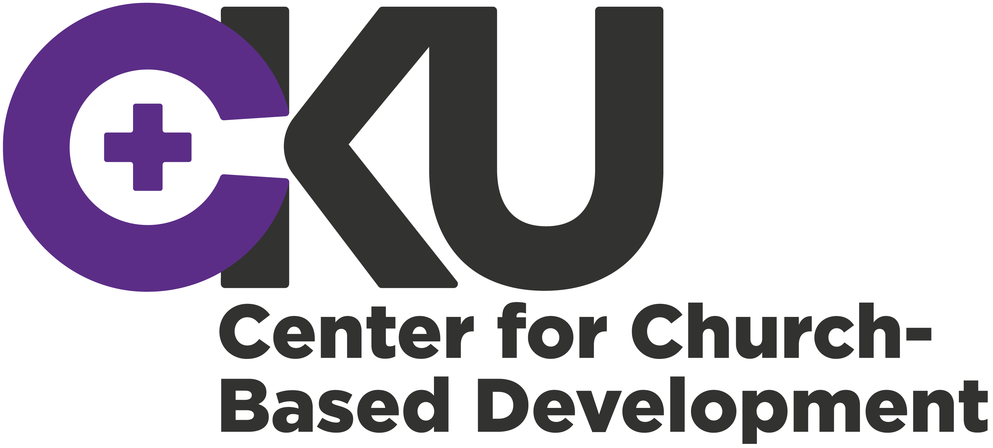

Application Format B for smaller projects
Jan 2021

This application format can be used for the following project types:
- B: Smaller project (maximum 500.000 DKK)
- B: Pilot project (maximum 500.000 DKK)

This Application Format includes:

- Front page with Basic information
Applicant (CKU member organisation and partner organisation), title, type of project, country of implementation, requested financing, summary (in Danish) and signatures.

- Application Text
Description of the proposed project. The Guidelines for the CKU Pool Fund provide assistance for the formulation of the application.

- Budget Summary
The main items of the budget drawn up for the project is in DKK. A separate detailed budget (local currency) should be attached to the application as an Annex A.

- List of Annexes
At the end of the application format a list of submitted annexes should be provided.

Please note:
- The seven evaluation criteria in the Guidelines for the CKU Pool Fund determines whether the application is qualified for funding or not.
- The application text should not exceed 10 pages (Cambria 11, line spacing 1.0) excluding front page and annexes. Applications exceeding the maximum number of pages will not be accepted.
- The application format includes some instructions in italic. These can be deleted before submission.
- The project application should be drawn up between the Danish partner organization and the partner organization. Consequently, the application is to be submitted in English.
- Annexes excluding the obligatory annexes A, B, C, and D should not exceed 20 pages.

Guidelines for the CKU Fund and Guidelines for budget formulation can be found on the CKU website: http://cku.dk/projektstoette/cku-puljen/
Formats for annexes and guide to Logical Framework Analysis can be found here: http://cku.dk/projektstoette/cku-puljen/skemaer-og-formater/

Submission:
The application form and all annexes are submitted electronically to the handling project consultant.
1. Front page with basic information

Reg. no. (To be filled by CKU)
CKU-

Project Title
Select type of project:
Smaller project ( ) yes / Pilot project ( ) yes
Countries /region: |  |  | GNI per capita:
Applicant:
CKU member organisation
Applicant:
partner organisation
Total project cost (incl. other and own contributions) | DKK |  |  | (local currency)
Amount requested from CKU | DKK |  |  | (local currency)
Average spending per year:  DKK | Project period:  (Max. 36 month) Months
Is this a re-submission?  ( ) No  ( ) Yes, previous date of application? | Is this a project in extension of another project  ( ) No ( ) Yes  Is this a project divided into several phases?  ( ) No ( ) Yes, phase (x) out of (x) phases
Date of Project start: |  | Date of Completion:
What Sustainable Development goals (SDG’s), if any, is relevant for the application:
Summary (maximum 10 lines in Danish including brief introduction to objectives, target group and main activities).

Signatures:
____________ __________________ _________________________________
Date (stamp) Name CKU member organisation

____________ __________________ _________________________________
Date Name Partner organisation

Has the member organisation and the partner received A or B Project grants from CKU the last two years?

Yes ☐ If yes, provide registration number for the application: CKU-
No ☐ Fill in Annex D about partnership.
If yes, describe if anything, relevant to the application, is new within the partner organization and partnership:

A. Application Text

A1. Why is the project relevant?
- What is the overall goal of the intervention and what issues (challenges or opportunities) in the local context makes it relevant?
(Please describe the relevant social, economic, political conditions as well as any relevant climate-, human rights /or gender related aspects. If, the project is implemented in a fragile context, describe the fragile context or situation).

What are the capacities and the legitimacy of the partner organisation in relation to the intervention’s subject, context and target group?

Is the project an extension of another project? Yes ☐ No ☐
- If yes, please describe results achieved and learning from former phases and what new key elements will be introduced in this project phase?
- If no, please describe the preparation of the intervention

A2: What long-term change will the project bring?
- What long-term change is the project expected to contribute to the poor, vulnerable and marginalised target group(s)?

What are the expected outcomes and key outcome indicators of the project?
Outcome (the change expected as an immediate result of the project) | Key indicators (what will be measured in relation to the set outcome)
1.1
1.2
Etc.

Please attach a full LFA matrix containing outcomes, outputs, indicators assumptions and risks. Press here to see the guideline for how to fill out a logframe for smaller projects.

A3: Who will be part of the intervention?
- Stakeholder analysis of key right-holders, duty-bearers and other stakeholders
Please describe key actors who have an interest in the project subject.
Press here to see the guideline for how to fill out a stakeholder analysis.

Key stakeholders | Who | Interest in/ fear of the project | Involvement in the project

NB: Your strategy for involving the different stakeholders should be reflected further on and unfolded more in detail in the application section A4: How will the project achieve the expected outcome?

- Target group
Please describe approximate number and general characteristics of the target groups.
Press here to see the guideline for how to fill out a target group analysis for smaller projects.

Ultimate target group  - the larger group of rights-holders (also known as beneficiaries) who will ultimately benefit from the project | Who and how many
 | Describe the general characteristics of the group e.g. location, socio-economic, gender and age.
Primary target groups  - the rights-holders and duty-bearers actively and directly involved in the project activities | Who and how many
 | Describe the general characteristics of the group e.g. location, socio-economic, gender and age.
Secondary target group  - the people indirectly or directly involved in the project (e.g. duty bearers, other actors etc.) | Who and how many
 | Describe the general characteristics of the group e.g. location, socio-economic, gender and age.
How has the target group participated in the formulation of the project?

A4: How will the project achieve the expected outcome?
- How will the project bring about change for the target group?
(What key steps and activities will the project take to bring about change? Sum up in what way the partner organisation will work with the stakeholders to achieve the long-term change? Describe how strategic service delivery, capacity building and advocacy is balanced).

Does the project work strategically with SDG’s: Yes ☐ No ☐
If yes, please specify which SDG’s and how you work strategically with these?

Does the project work strategically with gender: Yes ☐ No ☐
If yes, how do you work strategically with gender?

Does the project work strategically with freedom of religion and belief: Yes ☐ No ☐
If yes, how do you work strategically with freedom of religion and belief?

Does the project work strategically with development of the partner organisation in terms of legitimacy, institutional sustainability and representativity: Yes ☐ No ☐
If yes, how do you work strategically with development of the partner?

- How is the project organised and managed within the partner organisation?
Please describe the distribution of roles and responsibility of the partner organisation in project implementation. Describe how the target group is involved in the implementation of the project.

How will the project monitor and document progress? (Describe who will be responsible for monitoring, what methods will be used and with what frequency. Describe also how the project will be evaluated)

How will the project ensure and foster learning?

A5: Sustainability
- How will the intervention lead to long-lasting improvements for the target group?
Please describe how the change will be sustained and who will take responsibility to sustain the improvements?

A6: Public Anchorage
Must be filled in by the CKU member organisation
- How will the project work with public anchorage in the Danish organisation? E.g. through involvement of volunteers or information efforts.
Please describe the type of public anchorage and how it will be strengthened through the project.

B. Budget Summary
Here a summary of the main budget in DKK should be provided. (Budget in local currency should be provided in Annex A)
Main budget items: |  |  | Financing plan
 | Total budget in DKK |  | Of this, from CKU Fund | Of this, from other sources
- Activities
- Investments
- Local staff
- Local monitoring
- Local administration
- Danish project monitoring visit
- Reviews and evaluation
- Budget margin (min 6% & max 10% of 1-7)
- Project expenses in total (1-8)
- Auditing in Denmark
- Subtotal (9 + 10)
- Administration in Denmark (max 7% of 11)
- Total

Indicate total cost in local currency: | Indicate exchange rate applied:

Please note that budget lines 10-13 is only to be filled in if the Danish partner organisation is administrating the project as agreed upon prior to the submission of this application.

C. List of Annexes
Obligatory Annexes:
The following annexes must be submitted together with the application:
Annex A: Budget
Annex B: Fact sheet about the partner organisation and partnership
Annex C: Fact sheet about the Danish partner organisation (if self-administrating)
Annex D: Fact sheet about the partnership
Annex E: Logical Framework Analysis
Supplementary annexes (max 20 pages excluding annex A, B, C and D):
Annex no. | Annex title

