Application Format G for co-financing
Sep 2022

This application format can be used for the following project types:

- Co-financing (maximum 1.000.000 DKK). The co-financing may amount to a maximum of 25 % of the combined budget of the project or programme (however maximum DKK 1,000,000, but minimum DKK 500,000).

This Application Format includes:

- Front page with Basic information
Applicant (Danish organization and partner organisation), title, type of project, country of implementation, requested financing, information about the main donor and Call For Proposal (when relevant), summary (in Danish) and signatures.

- Application Text
A brief description is provided of the intervention’s relevance to the FoRB-Window in view of the main donor’s guidelines. Remember to also indicate the expected date of reply from the main donor.

- Budget Summary
Budget summary showing the FoRB Window’s contribution broken down by the main budget items used by the fund.
Kindly note that separate budget guidelines are available at https://cku.dk/projektstoette/torf-vindue/ to provide assistance to the budget formulation.

- List of Annexes
At the end of the application format, a list of mandatory and supplementary annexes should be provided.

Please note:
- The seven evaluation criteria in the Guidelines for the FoRB-Window determines whether the application is qualified for funding or not.
- The application text should not exceed 1 page for Co-financing projects) (Cambria 11, line spacing 1.0) excluding front page and annexes. Applications exceeding the maximum number of pages will not be accepted.
- The application format includes some instructions in italic. These can be deleted before submission.
- The project application should be drawn up between the Danish partner organisation and the partner organisation. Consequently, the application is to be submitted in English.

Guidelines for the FoRB-Window and Guidelines for budget formulation can be found on the CKU website: https://cku.dk/projektstoette/torf-vindue/.

Submission:
The application form and all annexes are submitted electronically to the handling project consultant.
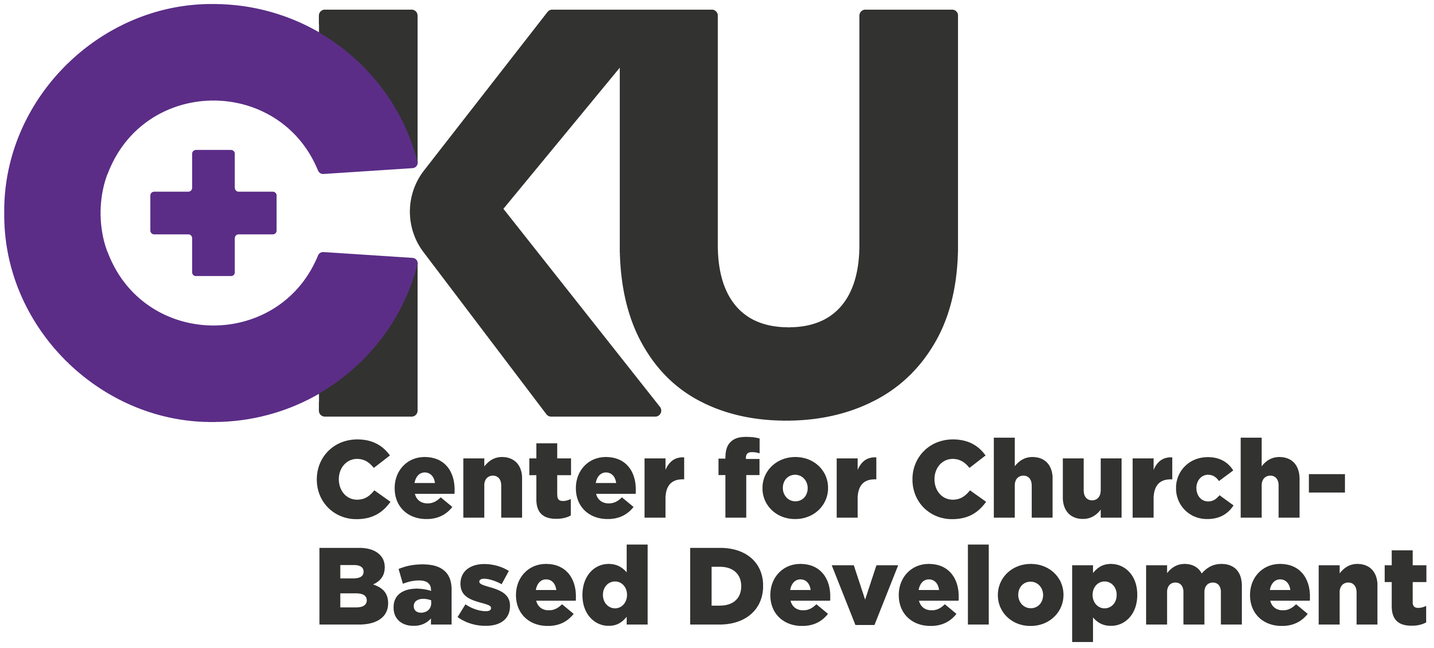
1. Front page with basic information
Reg. no. (To be filled by CKU)
CKU-

Project Title
Countries/region:
GNI per capita:
Applicant:
Danish organisation
Applicant:
partner organisation
Total project cost (incl. other and own contributions) | DKK |  | (local currency)
Amount requested from CKU | DKK |  | (local currency)
Average spending per year:  DKK | Project period:  (Max. 36 month) Months
Is this a re-submission?  ( ) No  ( ) Yes, previous date of application? | Is this a project in extension of another project  ( ) No ( ) Yes  Is this a project divided into several phases?  ( ) No ( ) Yes, phase (x) out of (x) phases
Date of Project start: |  | Date of Completion:
What Sustainable Development Goals (SDG’s), if any, is relevant for the application:
Main Donor (EU, UN etc):
Link for Call for Proposal:
Title of Call for Proposal:
Summary (maximum 10 lines in Danish including brief introduction to objectives, target group and main activities).

Signatures:
_________________ ___________________ __________________________________
Date (stamp) Name Danish organisation

_________________ ___________________ __________________________________
Date Name Partner organisation

Has the member organisation and the partner organization received TA or TB Project grants from CKU the last two years?

Yes ☐ If yes, provide registration number for the application: CKU-
No ☐ Fill in Annex D about partnership.
If yes, describe if anything, relevant to the application, is new within the partner organization and partnership:

A. Application Text

A1. Why is the project relevant in relation to the FoRB-Window?

B. Budget Summary
Here a summary of the main budget in DKK should be provided. (Budget in local currency should be provided in Annex A

Main budget items: |  |  | Financing plan
 | Total budget in DKK |  | Of this, from CKU Fund | Of this, from other sources
- Local Partner Activities
- Local Partner Investments
- Local Partner Staff and Volunteers
- Local Partner Administration
- External Evaluation
- DK Partner Activities & Project Monitoring
- DK Partner Project Support
- Total Project Costs
- Budget margin (From CKU min. 6% - max. 10% of #10)
- Disability Compensation
- Auditing DK Partner
- Total Costs
- Administration DK Partner if applicable (max 7% of #13)
- Grand Total

Indicate total cost in currency applied for with the main donor: | Exchange rate applied (please use www.oanda.com and provide date):

Please note that budget lines 11-13 is only to be filled in if the Danish partner organisation is administrating the project as agreed upon prior to the submission of this application.

C. List of Annexes
Obligatory Annexes:
The following annexes must be submitted together with the application:
Annex A | Guidelines: The relevant ’Guidelines for grant applicants’ (for EU co-financing) or the main donor’s guidelines for support are uploaded to the application facility.
Annex B | Fact sheet about the partner organisation
Annex C | Fact sheet about the Danish partner organisation (if self-administrating)
Annex D | Fact sheet about the partnership
Annex E | Application to main donor: The completed Concept Note (for EU co-financing) or application to the main donor
Annex F | Overall Budget: The Overall Budget submitted to the main donor.

